Create a new React Application with the name “myfirstreact”, Run the application to print “welcome to the first session of React” as heading of that page.

3.To create a React Application with the name of “myfirstreact”, type the following command:

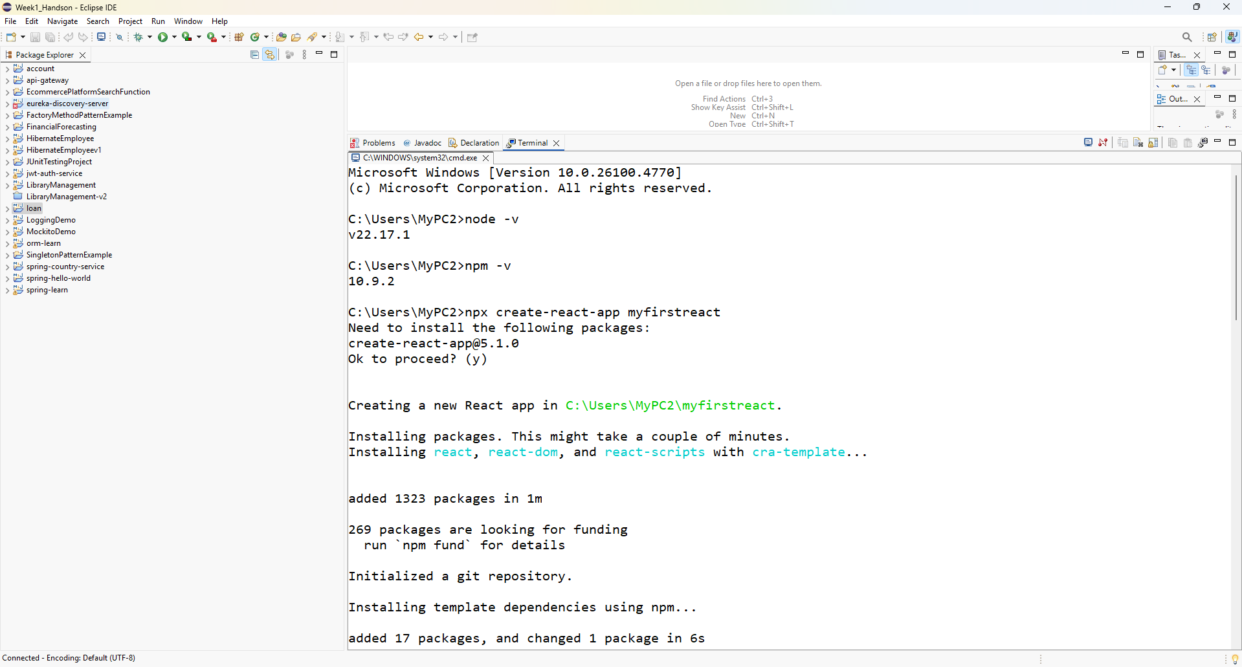

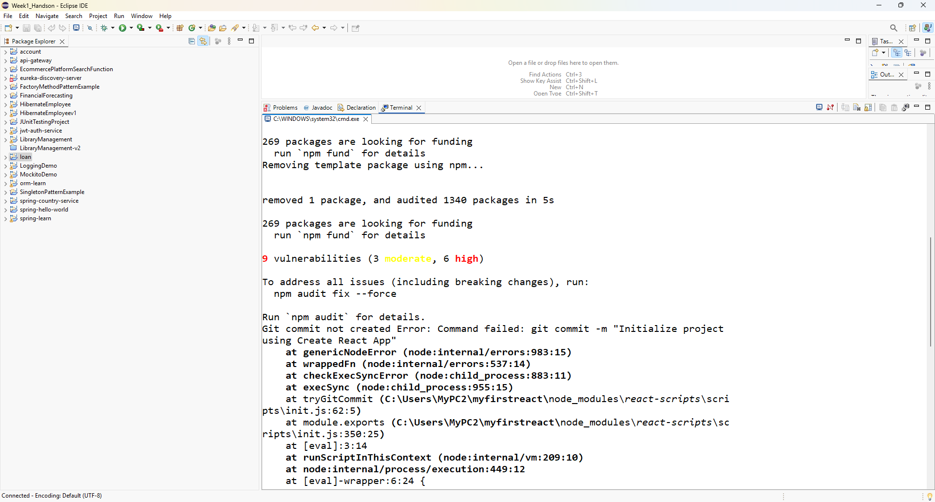

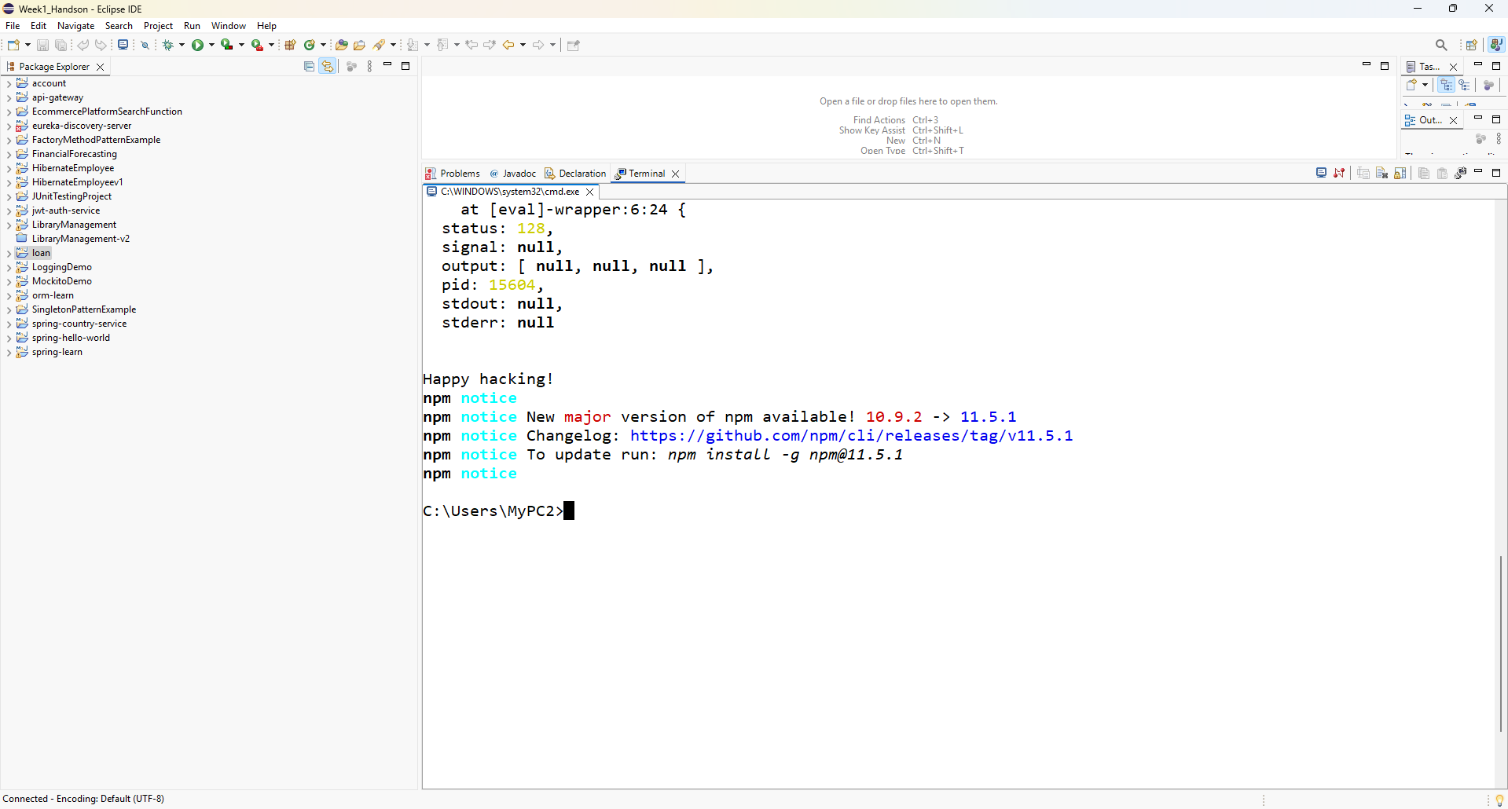

4.Once the App is created, navigate into the folder of myfirstreact by typing the following command:

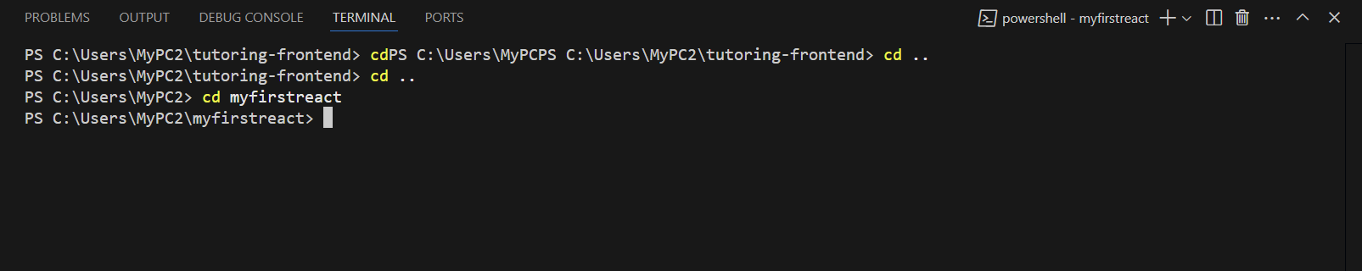

5.Open the folder of myfirstreact in Visual Studio Code

6.Open the App.js file in Src Folder of myfirstreact

7.Remove the current content of “App.js”

8.Replace it with the following:

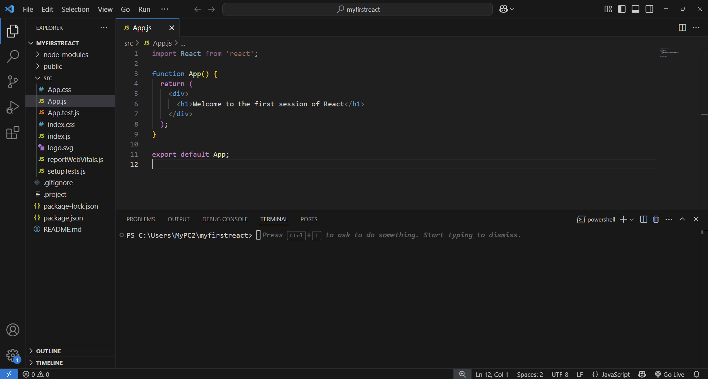

9.Run the following command to execute the React application:

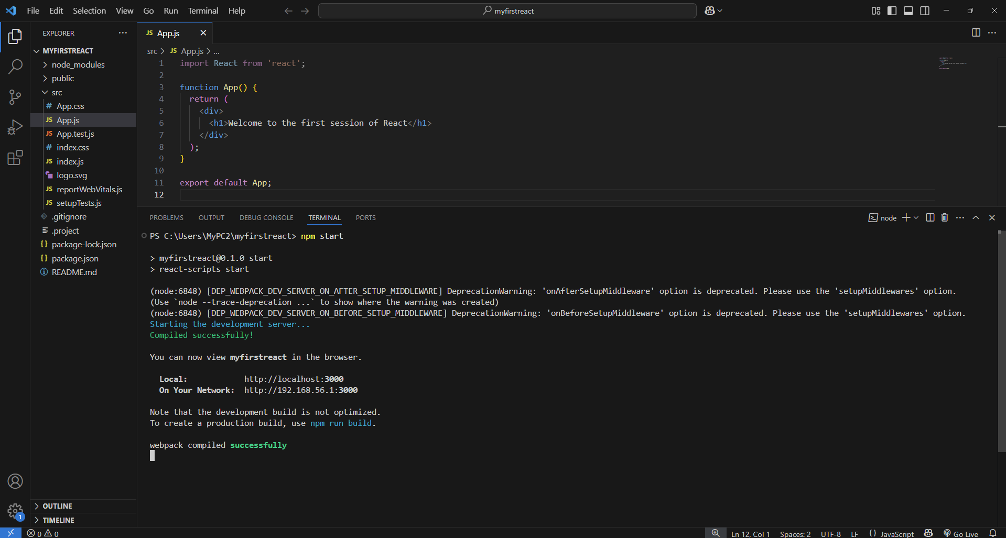

10. Open a new browser window and type “localhost:3000” in the address bar

